EXPERIMENT-40
AIM
To analyze soccer player data stored inside a Python program (without CSV) and identify top goal scorers, highest-paid players, average age, older players, and visualize position distribution.
ALGORITHM
- Create a list of dictionaries containing player details.
- Convert the list into a pandas DataFrame.
- Display the top 5 goal scorers.
- Display the top 5 highest-paid players.
- Calculate the average age.
- Display players older than the average age.
- Count players based on position.
- Visualize player distribution using a bar chart.
CODE:
import pandas as pd
import matplotlib.pyplot as plt

# Step 1: Create dataset manually
data = [
{"Name": "Ronaldo", "Age": 38, "Position": "Forward", "Goals": 28, "Salary": 900000},
{"Name": "Messi", "Age": 36, "Position": "Forward", "Goals": 30, "Salary": 950000},
{"Name": "Neymar", "Age": 31, "Position": "Forward", "Goals": 18, "Salary": 800000},
{"Name": "Modric", "Age": 37, "Position": "Midfielder", "Goals": 5, "Salary": 400000},
{"Name": "Kroos", "Age": 34, "Position": "Midfielder", "Goals": 4, "Salary": 350000},
{"Name": "Ramos", "Age": 36, "Position": "Defender", "Goals": 3, "Salary": 300000},
{"Name": "Van Dijk", "Age": 32, "Position": "Defender", "Goals": 2, "Salary": 320000},
{"Name": "Haaland", "Age": 23, "Position": "Forward", "Goals": 35, "Salary": 600000},
{"Name": "Mbappe", "Age": 25, "Position": "Forward", "Goals": 33, "Salary": 850000},
{"Name": "De Bruyne", "Age": 32, "Position": "Midfielder", "Goals": 10, "Salary": 450000}
]

# Step 2: Convert to DataFrame
df = pd.DataFrame(data)

# Step 3: Top 5 goal scorers
print("Top 5 Goal Scorers:")
print(df.sort_values(by="Goals", ascending=False).head(5))

# Step 4: Top 5 highest salaries
print("\nTop 5 Highest Salaries:")
print(df.sort_values(by="Salary", ascending=False).head(5))

# Step 5: Average age
avg_age = df["Age"].mean()
print("\nAverage Age of Players:", avg_age)

# Step 6: Players above average age
above_avg = df[df["Age"] > avg_age]
print("\nPlayers Above Average Age:")
print(above_avg[["Name", "Age"]])

# Step 7: Position count
pos_count = df["Position"].value_counts()

# Step 8: Bar chart
plt.bar(pos_count.index, pos_count.values)
plt.xlabel("Position")
plt.ylabel("Number of Players")
plt.title("Distribution of Players by Position")
plt.show()
OUTPUT:
Top 5 Goal Scorers:
Rank | Name | Age | Position | Goals | Salary
1 | Haaland | 23 | Forward | 35 | 600000
2 | Mbappe | 25 | Forward | 33 | 850000
3 | Messi | 36 | Forward | 30 | 950000
4 | Ronaldo | 38 | Forward | 28 | 900000
5 | Neymar | 31 | Forward | 18 | 800000

Top 5 Highest Salaries:
Rank | Name | Age | Position | Goals | Salary
1 | Messi | 36 | Forward | 30 | 950000
2 | Ronaldo | 38 | Forward | 28 | 900000
3 | Mbappe | 25 | Forward | 33 | 850000
4 | Neymar | 31 | Forward | 18 | 800000
5 | Haaland | 23 | Forward | 35 | 600000

Average Age of Players: 32.4

Players Above Average Age:

Name | Age
Ronaldo | 38
Messi | 36
Modric | 37
Kroos | 34
Ramos | 36
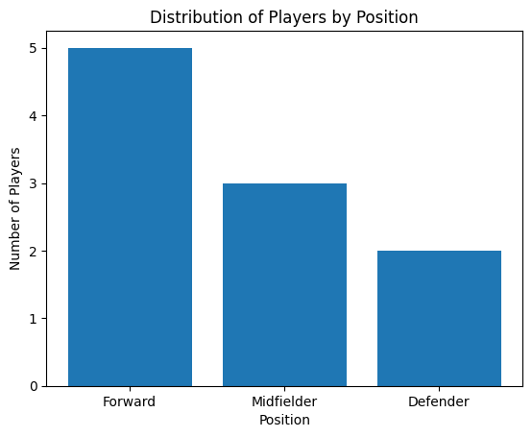
RESULT
The program identified the top goal scorers and highest-paid players, calculated the average player age, listed players above the average age, and visualized player positions using a bar chart.

